**DBDA Sept 2022 Data Visualization Exam**

|  |  |
| --- | --- |
| Name | Shakti Singh |
| Roll No. | 220943025035 |
| Paper Set No. | 1 |
| Date | 02/02/2023 |
| Tableau Public URL | https://public.tableau.com/app/profile/shakti.singh5764 |

1. Put your Question 1 answer screen shots below

1)

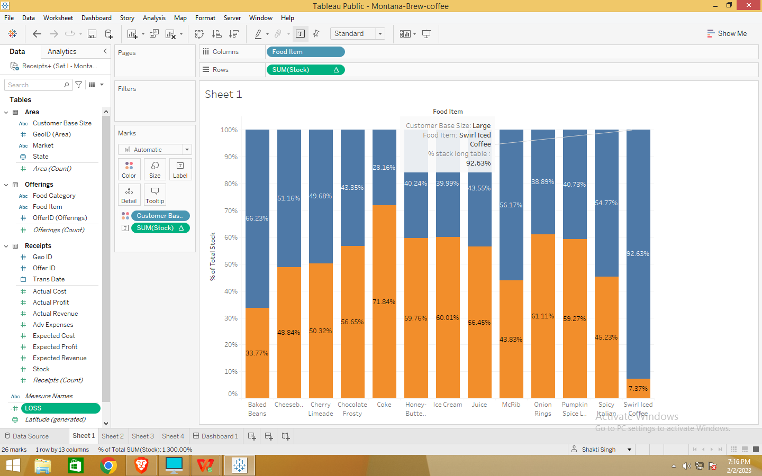

2)

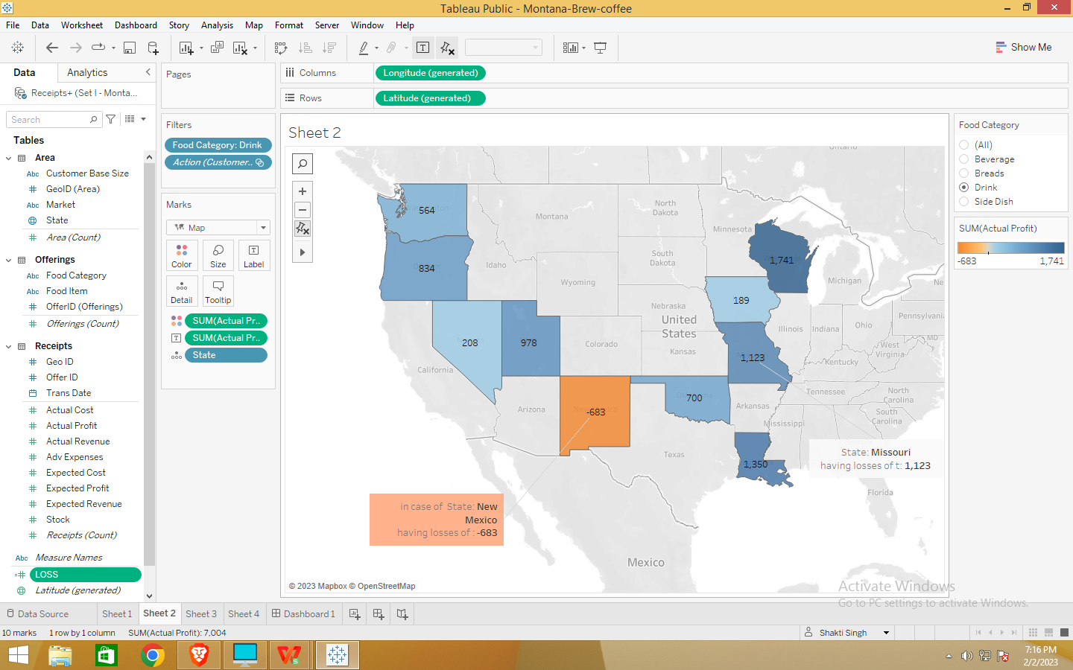

3)

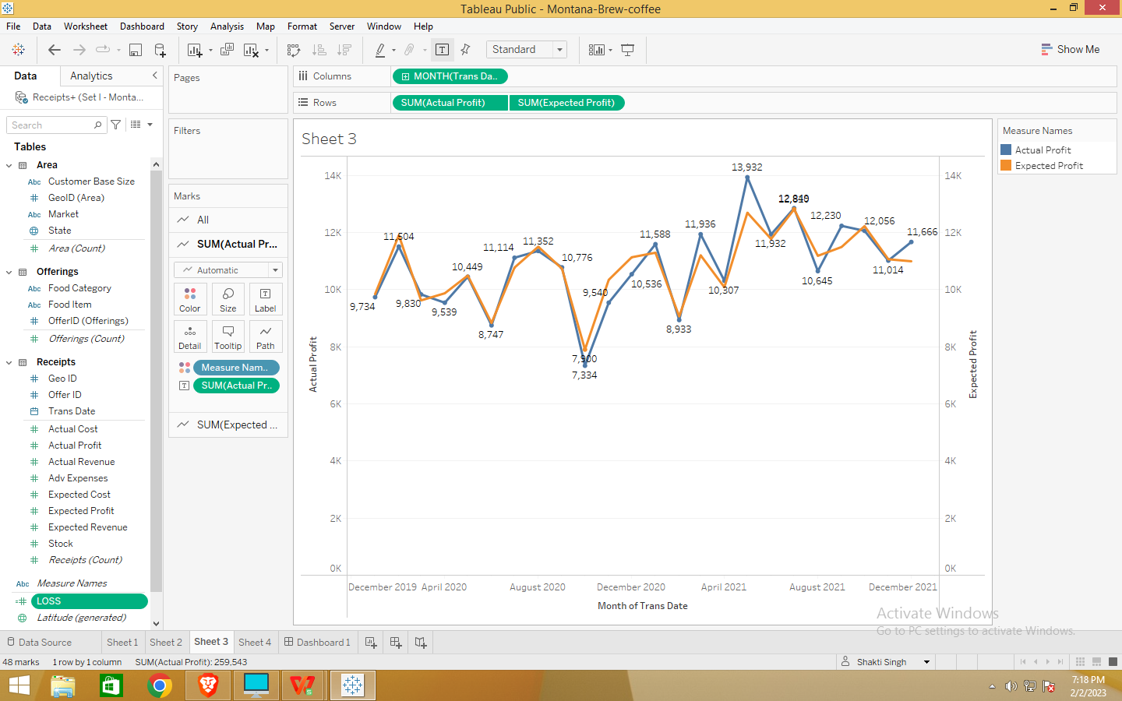

4)

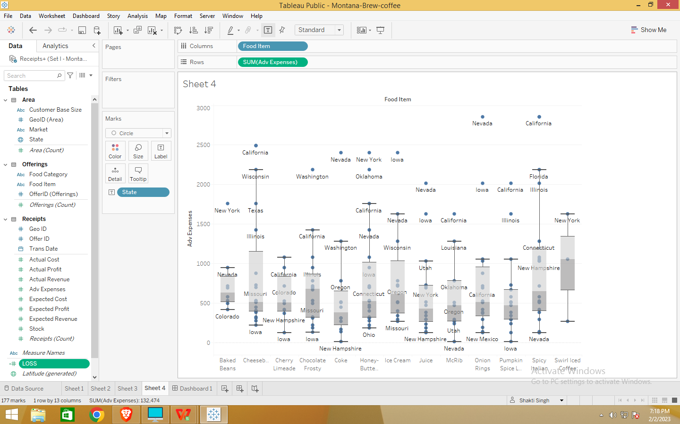

5)

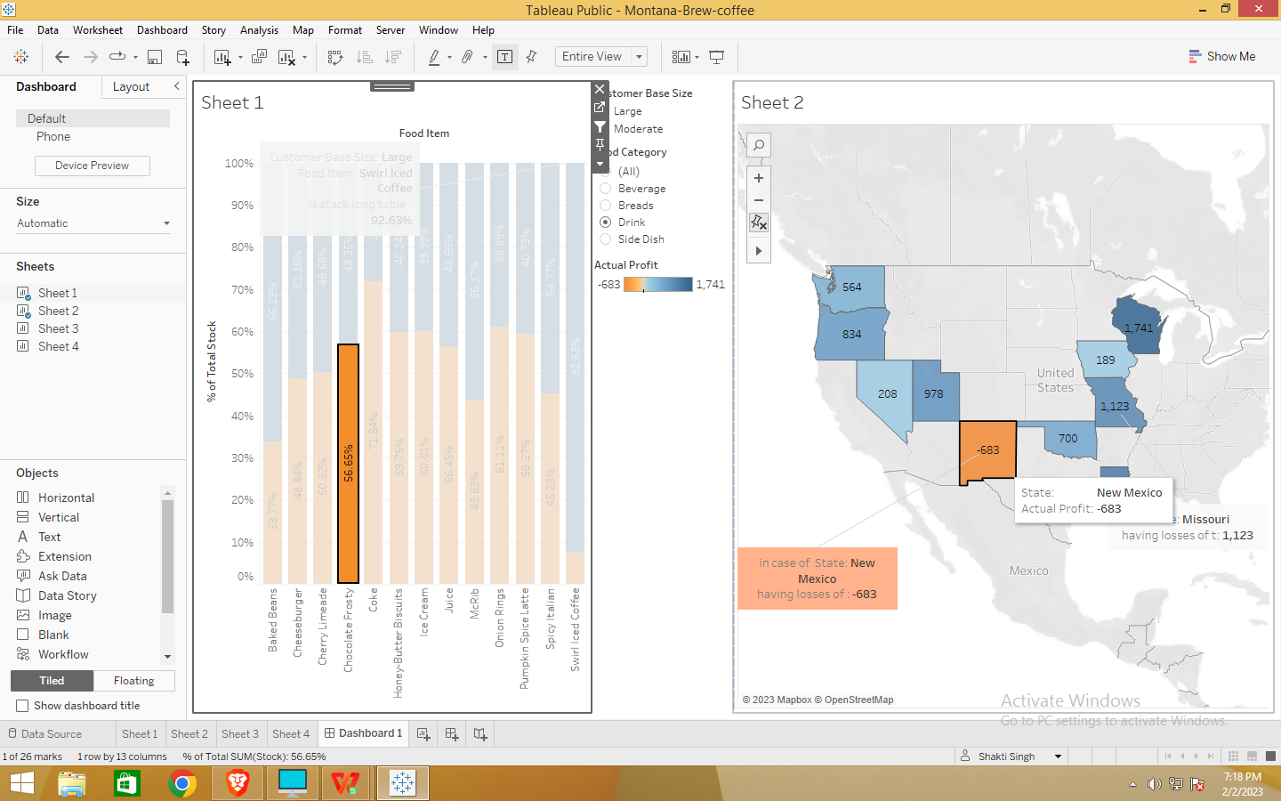

1. Put your Question 2 answer screen shots below

1)

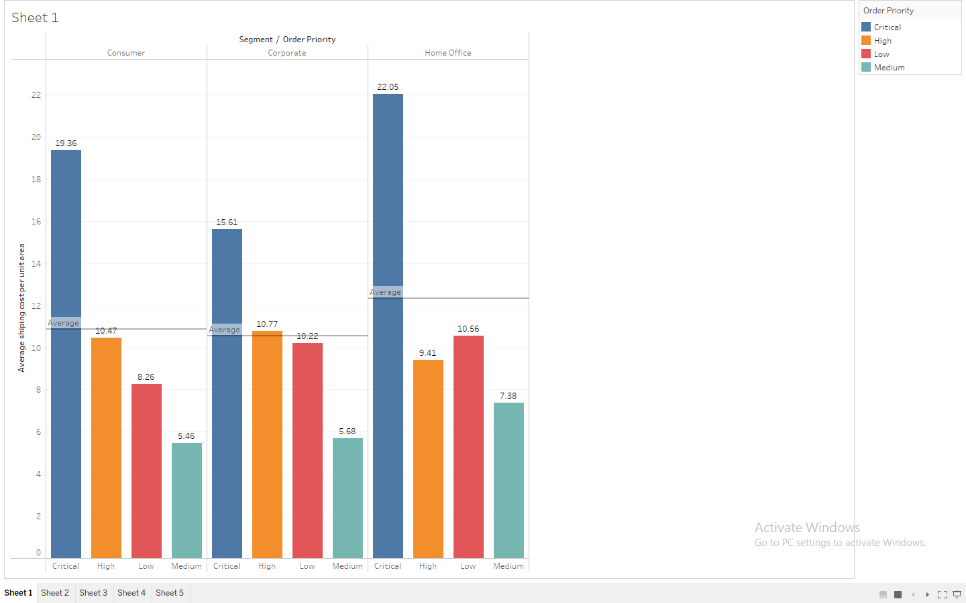

2)

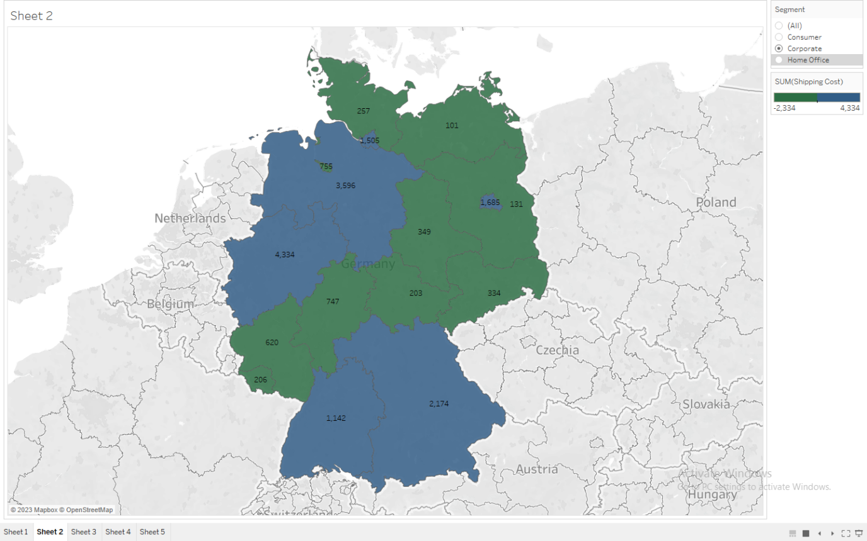

3)

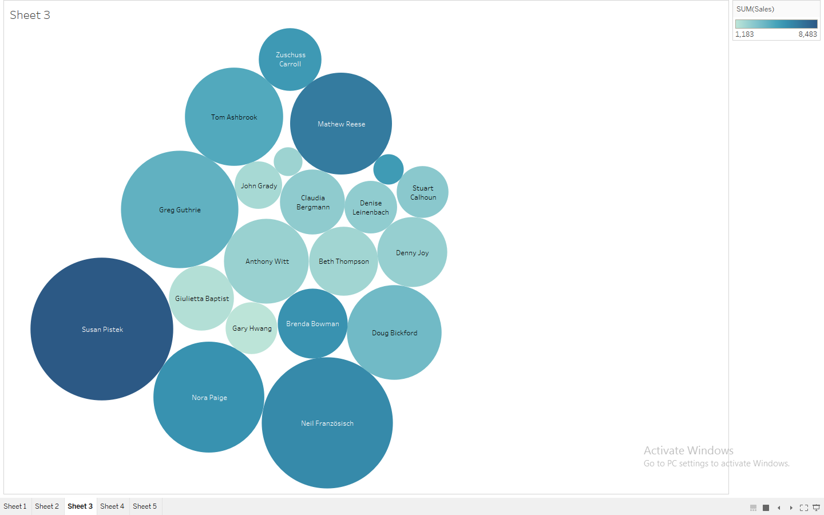

4)

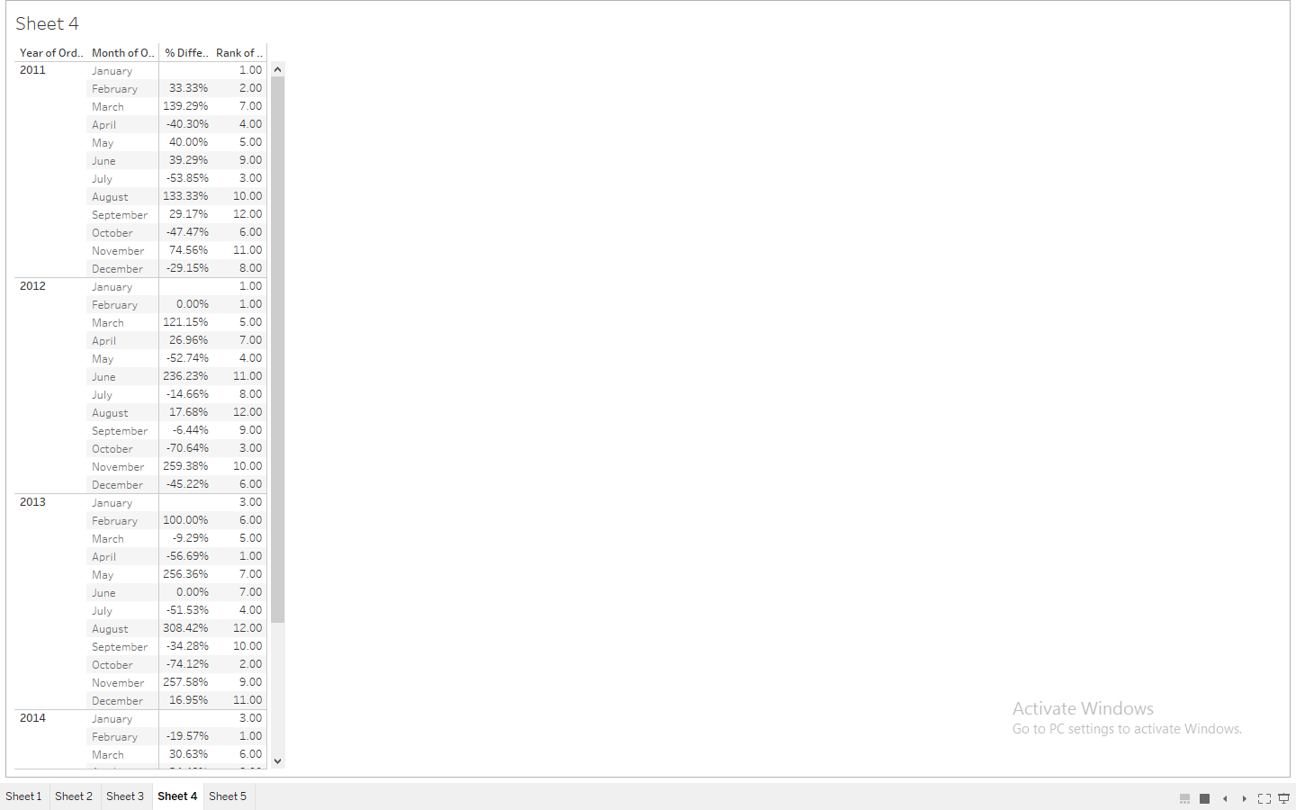

5)

